WEB DEVOLOPMENT ASSINGMENT-1

Challenge-1: Write a JavaScript to design a simple calculator to perform the following operations: sum, product, difference and quotient.

**Answer :**

**Index.html**

<!DOCTYPE html>

<html>

<head>

<title>challenge 1</title>

<link rel="stylesheet" href="./style1.css" />

</head>

<body>

<h1 style="text-align:center" > A SIMPLE CALCULATOR PROGRAM </h1>

<table >

<tr>

<td colspan="4" id="results">0</td>

</tr>

<tr>

</tr>

<tr>

<td><button onclick="pushBtn(this);">7</button></td>

<td><button onclick="pushBtn(this);">8</button></td>

<td><button onclick="pushBtn(this);">9</button></td>

<td><button onclick="pushBtn(this);">/</button></td>

</tr>

<tr>

<td><button onclick="pushBtn(this);">4</button></td>

<td><button onclick="pushBtn(this);">5</button></td>

<td><button onclick="pushBtn(this);">6</button></td>

<td><button onclick="pushBtn(this);">*</button></td>

</tr>

<tr>

<td><button onclick="pushBtn(this);">1</button></td>

<td><button onclick="pushBtn(this);">2</button></td>

<td><button onclick="pushBtn(this);">3</button></td>

<td><button onclick="pushBtn(this);">-</button></td>

</tr>

<tr>

<td><button onclick="pushBtn(this);">C</button></td>

<td><button onclick="pushBtn(this);">0</button></td>

<td><button onclick="pushBtn(this);">=</button></td>

<td><button onclick="pushBtn(this);">+</button></td>

</tr>

</table>

<script type="text/javascript" src="./scripts.js"></script>

</body>

</html>

**Style.css**

table,td,th {

border:thick;

text-align: center;

background-color: rgba(0, 183, 255, 0.445);

margin:auto ;

border-radius: 8px;

border-spacing: 0.2cm;

height : 0.5cm;

width: 2cm;

}

input {

text-align: center;

margin:auto

}

button{

background-color:rgb(0, 183, 255);

border-radius: 4px;

margin: auto;

height : 1cm;

width : 1cm;

}

**Scripts.jss**

results = document.getElementById('results');

function pushBtn(obj) {

var pushed = obj.innerHTML;

if (pushed == '=') {

// Calculate

results.innerHTML = eval(results.innerHTML);

if (results.innerHTML == Infinity){

alert ('cant divide by Zero')

results.innerHTML = "0"

}

}

else if (pushed == 'C') {

// All Clear

results.innerHTML = '0';

}

else {

// insert into the input

results.innerHTML += pushed;

}

}

**Output :**

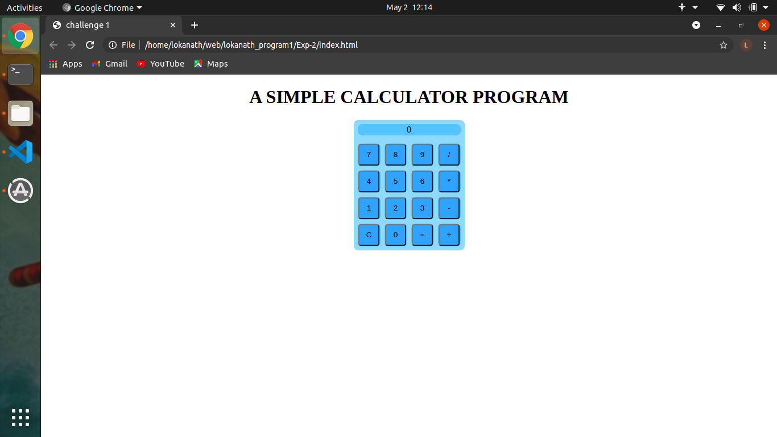

**Test Cases :**

|  |  |  |  |  |
| --- | --- | --- | --- | --- |
| Test No. | Input Parameters | Expected Output | Obtained Output | Remarks |
|  |  | Addition =74.95 | Addition =74.95 | PASS |
| 1. | value1=50.56 | Subtraction =26.17 | Subtraction =26.17 |
|  | value2=24.39 | Multiplication=1233.1584 | Multiplication=1233.1584 |
|  |  | Division=2.072980729807298 | Division=2.072980729807298 |
| 2. |  | Addition =45 | Addition =45 | PASS |
|  | value1= 0 | Subtraction =-45 | Subtraction =-45 |
|  | value2= 45 | Multiplication=0 | Multiplication=0 |
|  |  | Division=0 | Division=0 |
| 3. | value1= 45  value2= 0 | Addition =45 | Addition =45 | PASS |
| Subtraction =45 | Subtraction =45 |
| Multiplication=0 | Multiplication=0 |
| Division=Infinity (Displays alert) | Division=Infinity (Displays alert) |